

**Q1 (20%)** Video 1-5 seconds

**Mouse Hover Image Switch Effect**

Design a webpage to implement an image switching effect on mouse hover. Requirements are as follows:

1. The default image displayed should be ntub1.jpg.
2. When the mouse hovers over the image, it should switch to ntub2.jpg.
3. When the mouse moves away, the image should switch back to ntub3.jpg.
4. The image should have a border of 5px with the color #484848, and its size should be 500px × 350px.

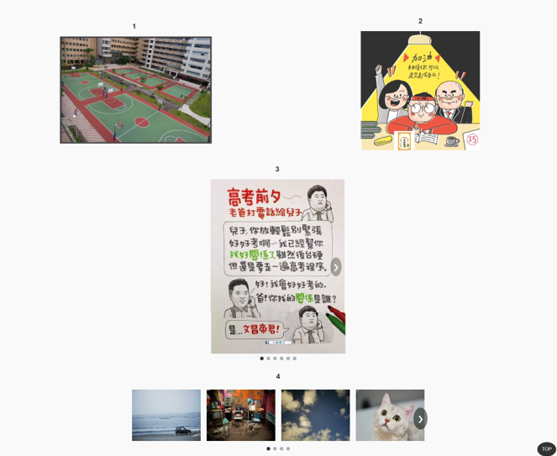

**Q2 (20%)** Video 6-19 seconds

**Animated Image within a Container**

Design an animation effect for an image. Requirements are as follows:

1. The background image should be static/4.jpg, sized at 400px × 400px, centered, and fully covered.
2. Place an animated image (60px × 60px) on top of the background, using the image static/5.jpg.
3. The animated image should move around the four edges of the container and scale between 1.0 to 1.5 times its size during movement.
4. Clicking the animated image pauses the animation, and clicking it again resumes the animation.



**Q3 (20%)** Video 20-30 seconds

**Single Image Carousel**

Implement a single-image carousel functionality based on the following requirements:

1. The carousel images should cycle through static/6.jpg to static/11.jpg.
2. Add left and right arrow buttons to navigate between images.
3. The left arrow should hide when the first image is displayed, and the right arrow should hide when the last image is displayed.
4. Add a dot indicator at the bottom of the carousel to show the current image's position. Clicking a dot should switch directly to the corresponding image.



**Q4 (20%)** Video 31-44 seconds

**Multiple Image Sliding Gallery**

Create a multiple-image sliding gallery. Requirements are as follows:

1. The images should range from static/21.jpg to static/33.jpg, with 4 images displayed at a time.
2. Add left and right arrow buttons to navigate between groups of images.
3. The left arrow should hide when the first group is displayed, and the right arrow should hide when the last group is displayed.
4. Add a dot indicator at the bottom of the gallery to show the current group’s position. Clicking a dot should switch directly to the corresponding group of images.



**Q5 (20%)** Video 45-57seconds

**Responsive Web Design (RWD)**

Adapt the multiple-image sliding gallery (Q4) for responsive design. Requirements are as follows:

1. By default, display 4 images at a time.
2. When the screen width is less than 768px, display 2 images per view.
3. When hovering over an image, it should zoom in and display a shadow effect.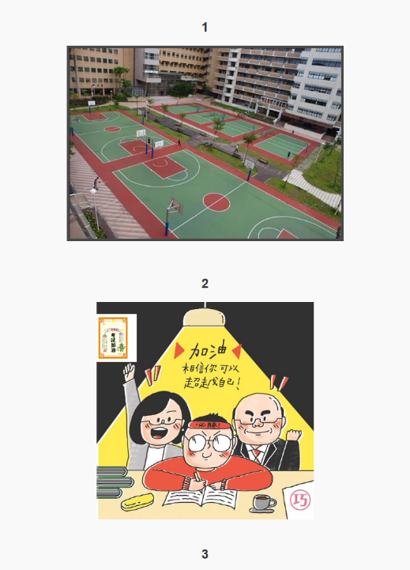

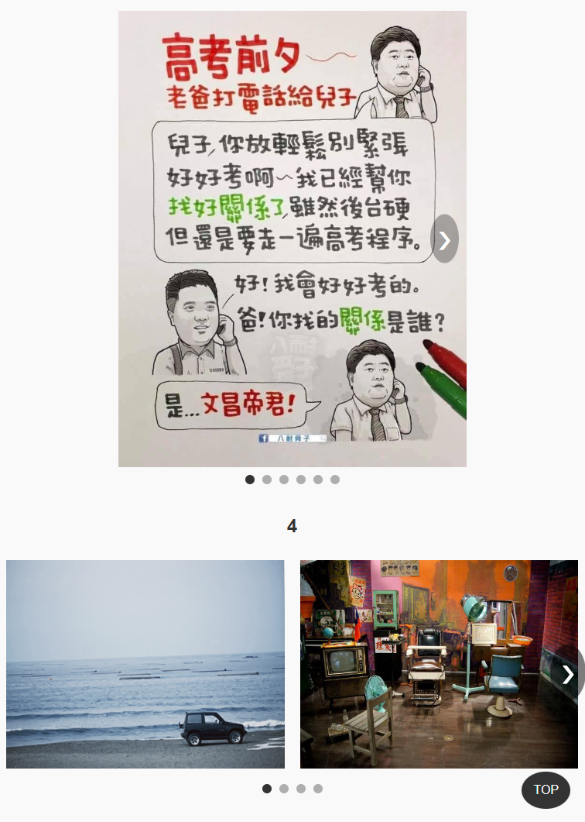

**Q6 (20%)** Video 57-60 seconds

**Back to Top Button**

Design a "Back to Top" button with the following requirements:

1. The button should appear when the user scrolls more than 200px down the page and disappear otherwise.
2. Clicking the button should smoothly scroll the page back to the top.
3. Button design:
   * Fixed position at the bottom-right corner (20px from both the bottom and the right).
   * Background color: #333, changing to #555 on hover.
   * Circular design with a size of 50px × 50px and the text "TOP" in the center.

